A000-Asia-China-Zhou-Yǒu-Bronze-1045 BCE

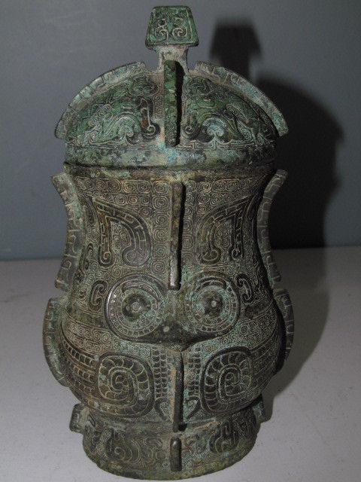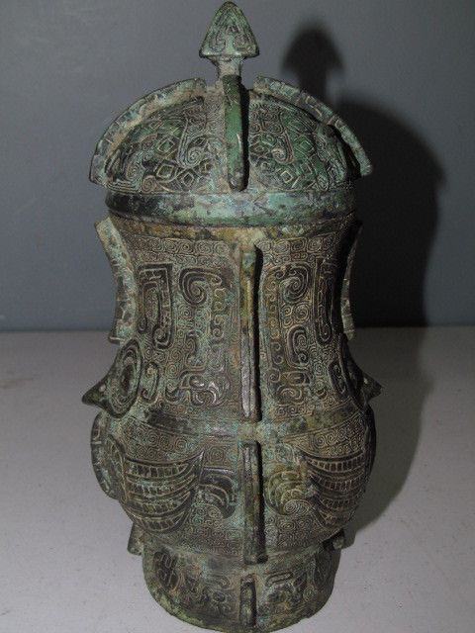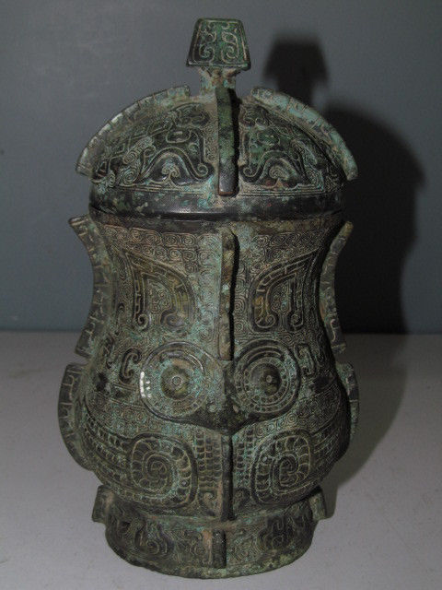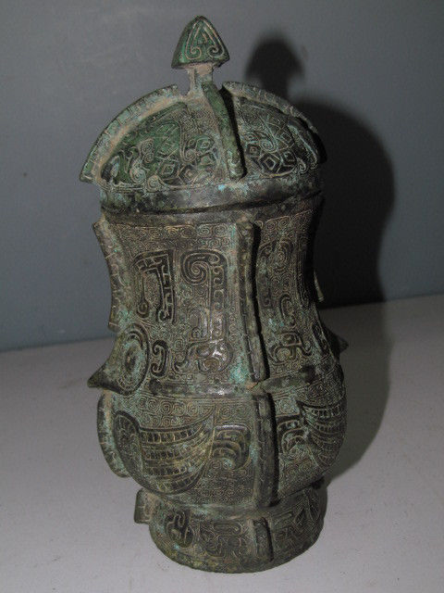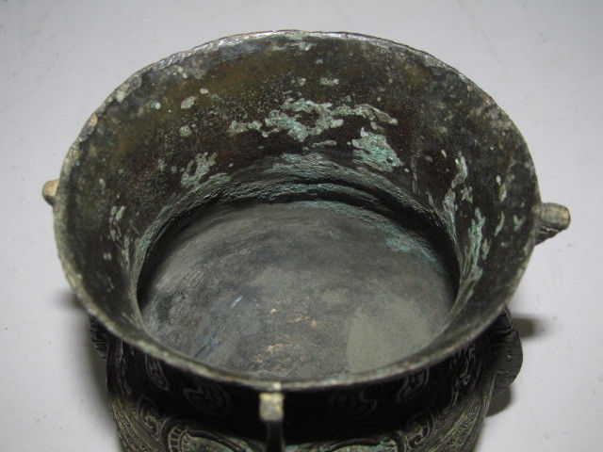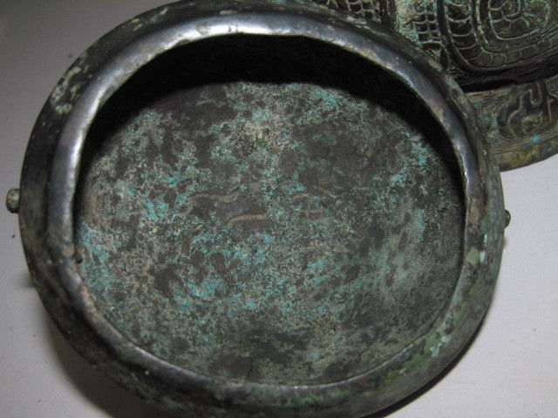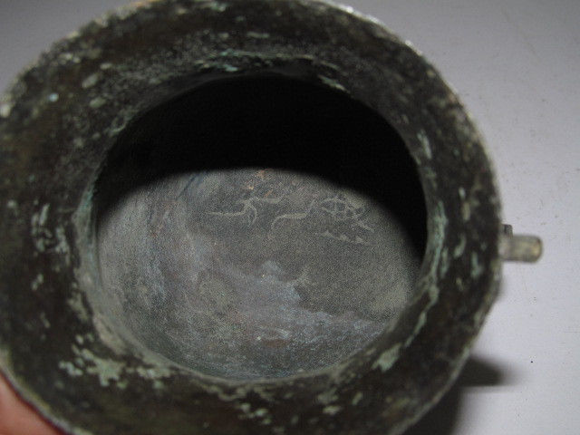

Case No.: 5

Accession No.

Formal Label:

**Display Description:**

This [Yǒu](https://en.wikipedia.org/wiki/You_(vessel)) lidded vessel was used for liquid offerings during the [Shang](https://en.wikipedia.org/wiki/Shang_Dynasty) and Zhou Dynasties. This vessel has a single round base.

**LC Classification:**

Date or Time Horizon:

Geographical Area:This vessel resembles those from Liulihe Township, Fangshan District, Beijing. The ancient city at Liulihe measured 3.5 km (2.2 mi) from east to west and 1.5 km (0.93 mi) from north to south, covering an area of 5.25 km2 (2.0 sq mi).[[2]](https://en.wikipedia.org/wiki/Western_Zhou_Yan_State_Capital_Museum" \l "cite_note-autogenerated2-2) Some 829 m (2,720 ft) of the north wall and 300 m (980 ft) of the west wall still remain and are visible in the farmland around the museum.[[3]](https://en.wikipedia.org/wiki/Western_Zhou_Yan_State_Capital_Museum" \l "cite_note-autogenerated1-3)[[4]](https://en.wikipedia.org/wiki/Western_Zhou_Yan_State_Capital_Museum" \l "cite_note-autogenerated4-4) A moat 2 m (6.6 ft) deep surrounded the city.[[3]](https://en.wikipedia.org/wiki/Western_Zhou_Yan_State_Capital_Museum" \l "cite_note-autogenerated1-3) A palace was located inside the city just north of city center with sacrificial sites and living quarters nearby.[[3]](https://en.wikipedia.org/wiki/Western_Zhou_Yan_State_Capital_Museum" \l "cite_note-autogenerated1-3)Cemeteries located outside the city to the southeast are divided by the Beijing-Guangzhou Railway into Sectors I and II. Sector I, from the Shang Dynasty, is smaller in size and contains remnants of human and dog sacrifice.[[3]](https://en.wikipedia.org/wiki/Western_Zhou_Yan_State_Capital_Museum" \l "cite_note-autogenerated1-3) Sector II, possibly from the Zhou Dynasty, contains greater numbers of large- and medium-sized tombs of nobles with chariots and rich set of burial items.[[3]](https://en.wikipedia.org/wiki/Western_Zhou_Yan_State_Capital_Museum" \l "cite_note-autogenerated1-3) In all, 200 tombs have been found, with the largest containing 42 sacrificed horses. Several thousand ceramic, ivory, jade, bone, lacquer and bronze artifacts including bronze ceremonial vessels and weapons have been found at the Liulihe Site.[[3]](https://en.wikipedia.org/wiki/Western_Zhou_Yan_State_Capital_Museum" \l "cite_note-autogenerated1-3)

The most historically-significant discovery at Liulihe is M1193, the tomb of the Marquis of Yan, which yielded two inscribed bronzes.[[5]](https://en.wikipedia.org/wiki/Western_Zhou_Yan_State_Capital_Museum" \l "cite_note-Yan_2006-5) These two bronzes memorialize exchanges between Yan, the vassal state, and the Kings of the Zhou Dynasty.[[5]](https://en.wikipedia.org/wiki/Western_Zhou_Yan_State_Capital_Museum" \l "cite_note-Yan_2006-5) The inscriptions on the bronzes describe investiture ceremony and the enfeoffment of the vassal State of Yan to the Duke of Shao.[[5]](https://en.wikipedia.org/wiki/Western_Zhou_Yan_State_Capital_Museum" \l "cite_note-Yan_2006-5) The inscriptions corroborate the Records of the Grand Historian, which states that when King Wu of Zhou defeated the Shang Dynasty and founded the Zhou Dynasty in 1045 BCE, he conferred titles of nobility to vassal rulers in his domain. Among those receiving titles were the rulers of the States of Ji and Yan, two states located in modern-day Beijing Municipality. The capital of Yan at Liulihe has been established with considerable certainty through archaeological evidence at Liulihe. The capital of Ji, is believed to be located further north, near modern-day Guang'anmen in Xicheng

**Map:**

**GPS coordinates:**

Cultural Affiliation:

Media:

Dimensions: length: 5 inches; width: 4 inches; height: 8 inches

Weight: 5 kg

Condition: original

Provenance:

**Discussion:**

**References:**

Sing, Yu; Caron Smith. 1999. Ringing Thunder- Tomb Treasures from Ancient China. San Diego: San Diego Museum of Art.